**Pig Script:**

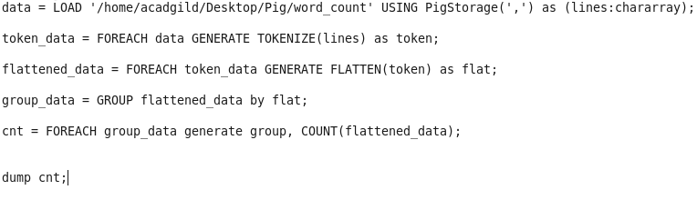

1. First splits each line into words using the TOKENIZE operator.
2. The tokenize function creates a bag of words.
3. Using the FLATTEN function, the bag is converted into a tuple.
4. In the third statement, the words are grouped together so that the count can be computed which is done in fourth statement.

**Result:**

Word-count

